**BandTracker Setup & Maintenance**

* Our web host, OVH.com, offers various packages with several levels of backup availability. There are options to purchase a snapshot backup or backup storage. With our basic level hosting we receive weekly backups from OVH itself.
* We have additional backup options through WordPress and Joomla backup plug-ins/extensions.

**Domain Registration**

* We registered www.bandtracker.ca through Canspace Solutions ([www.canspace.ca](http://www.canspace.ca)).

ttps://www.canspace.ca/images/logo.png

**Domain Name System**

* The domain name management was easily configurable through the Canspace web interface. The records we set are detailed below.

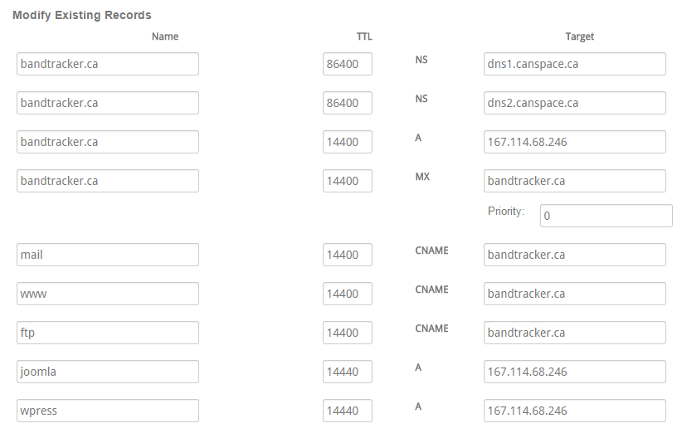

**Email**

* The mail setup process was fairly simple. We installed Postfix and Mailutils using the command line.
* Some configuration was required in the /etc/postfix/main.cf file to set the hostname and enable virtual alias maps.
* The creation of a virtual file with the domain email addresses was required. We then executed the postmap command on our virtual file.

**Search Engine Optimization**

Keyword Optimization

|  |  |  |
| --- | --- | --- |
| Band | Tracker | Favorite |

Applied Strategies

WordPress

An XML sitemap was created to assist Google’s crawler and to also assist other crawlers such as Bing and Yahoo. This file lists the URLs in the site for a crawler to easily see and also provides some additional information.

URL addresses are designed in a categorized, semantic, and human readable way.

Each page contains a unique title, meta info, and category tags.

Other plug-ins such as “WordPress SEO by Yoast” would be used to enhance SEO optimization on a specific and per page basis in the future. Google Analytics would also be integrated with more than the general information that Googlebot would scrape.

Joomla

XML sitemap created to again assist search engines in indexing the Joomla version of the website.

URL addresses are cleaned to be human readable for search bots and people.

In the future we would find extensions that provide more fine tuned control over the specifics of SEO optimization for the site. We would research more deeply into Google’s guidelines for rising high in organic search results and apply all concepts possible to improve the optimization of BandTracker on the Joomla identifying sub-domain.